Step by step to GitHub pages
Introduction to GitHub Pages
GitHub Pages is a free hosting service offered by GitHub that allows you to publish static websites directly from a GitHub repository.
It’s perfect for hosting:
- Personal portfolios
- Project documentation
- Resume sites
- HTML/CSS/JavaScript apps
- Static landing pages
Key Features:
- Free to use
- No server setup required
- Directly integrates with your GitHub repository
- Supports custom domains
- Automatically updates your site when you push changes to your repository

Prerequisites:
- A GitHub account: Sign up here if you don't have one.
- Basic knowledge of Git or GitHub interface.
- A static project folder (with files like index.html, style.css, script.js).

Step 1: Create a New Repository
- Go to https://github.com.
- Click + (top-right) → New repository.

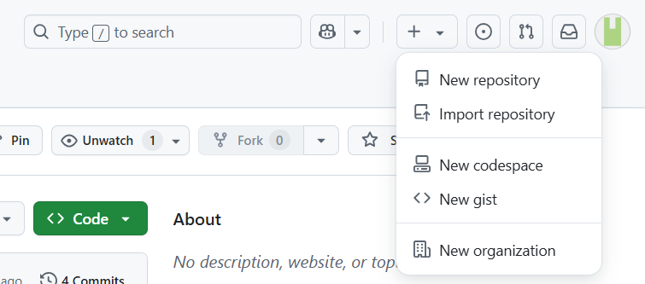

- Give it a name (e.g., simple_html_pages).
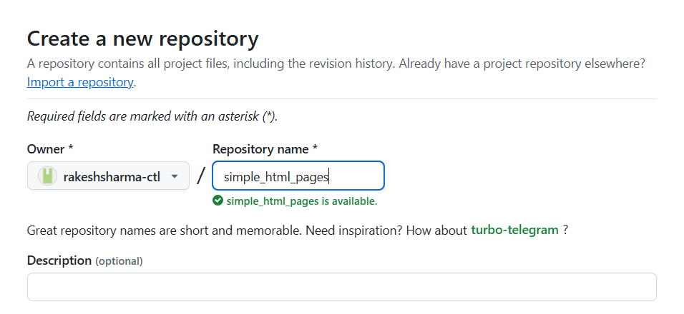

- Select: Public (Initialize this repository with a README)
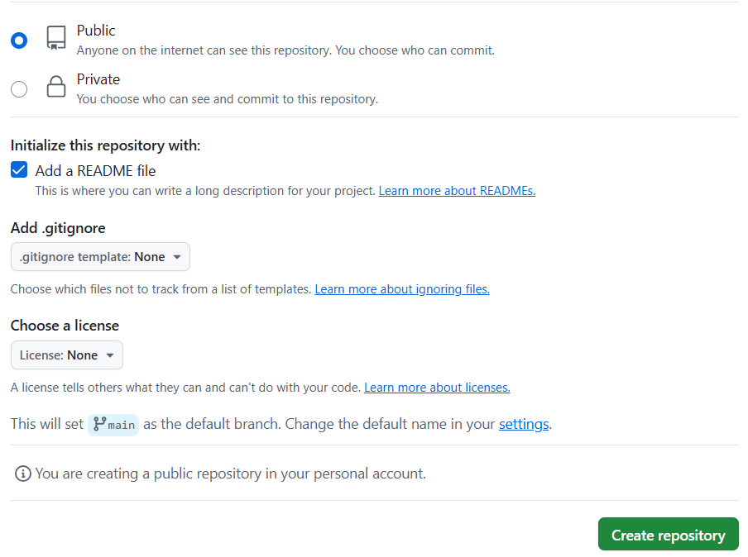
- Click Create repository.

Step 2: Upload Your Files
- Option A: Use GitHub Web UI
- Open the repository.
- Click "Add file" → "Upload files".

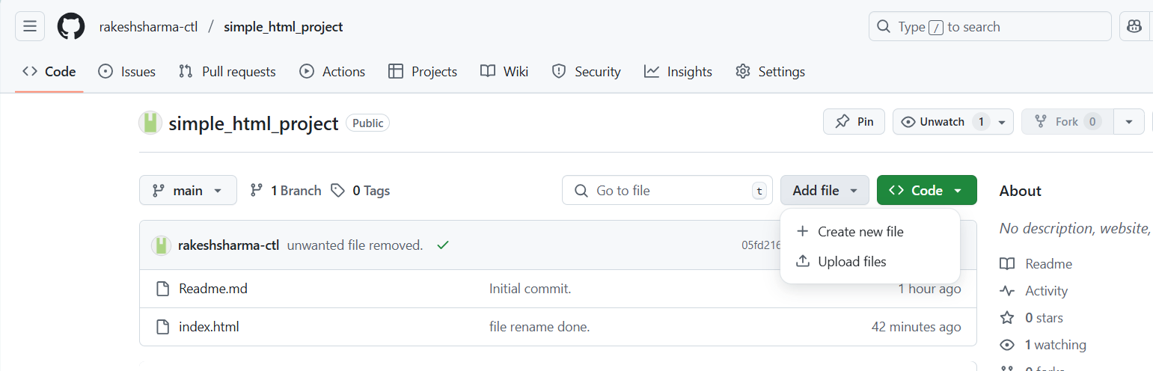

- Drag and drop your index.html, style.css, etc.
- Click Commit changes.

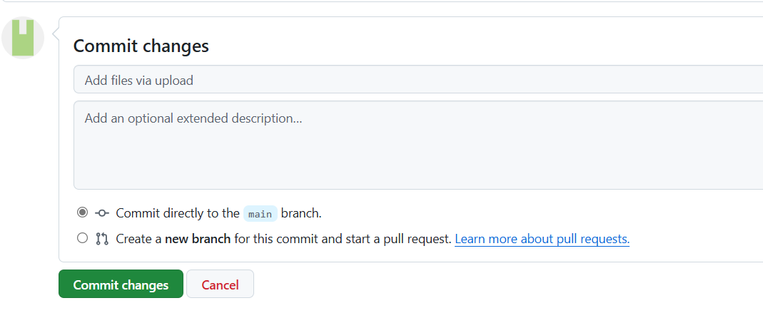

If you want to do it from your terminal, then follow the code below.
1. # On your computer terminal
2. git clone https://github.com/your-username/simple_html_pages.git
3. cd simple_html_pages
4. # Copy your files into this folder
5. git add .
6. git commit -m "Add static site files"
7. git push origin main

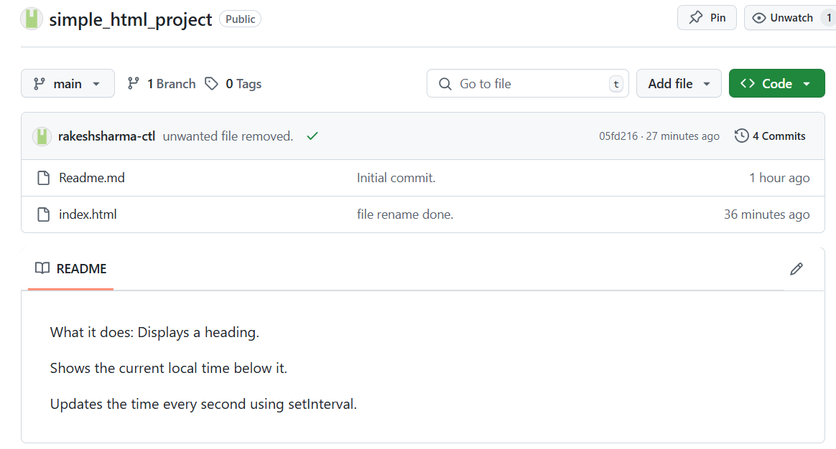
Files added.

Step 3: Enable GitHub Pages
- Go to your repository on GitHub.
- Click Settings (⚙️ top menu).
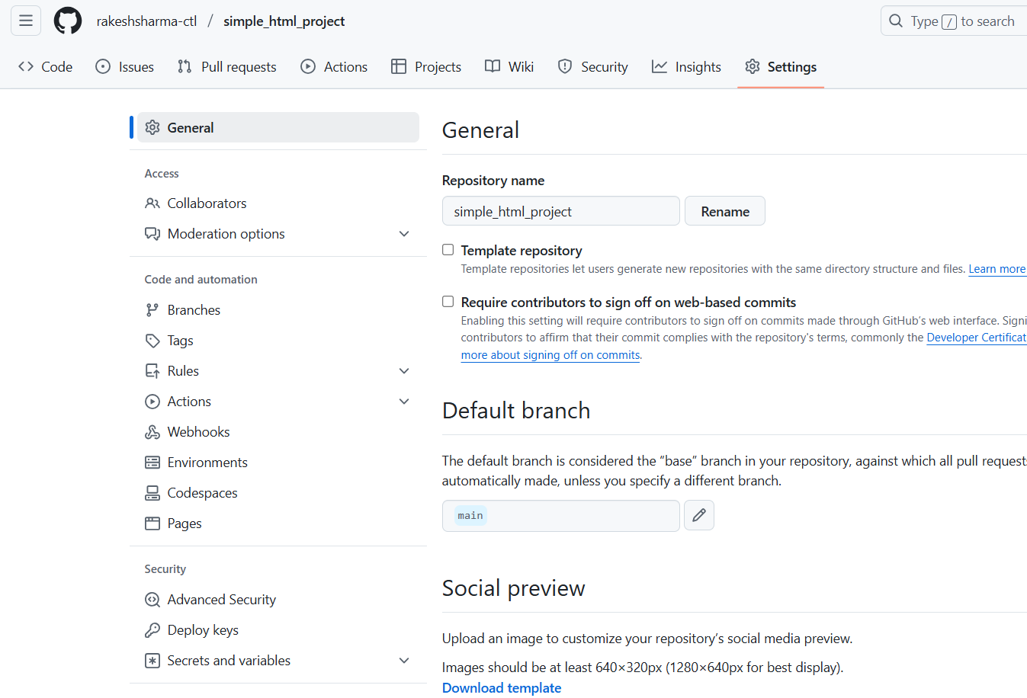

- In the left sidebar, go to "Pages".
- Under "Build and deployment", set:

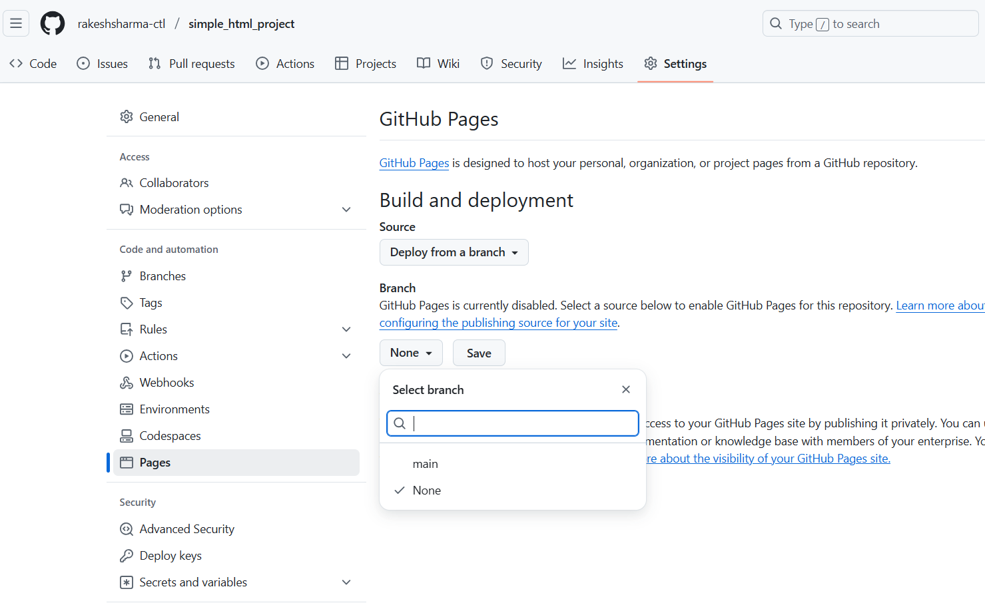

- Source: Deploy from a branch
- Branch: main
- Folder: / (root)
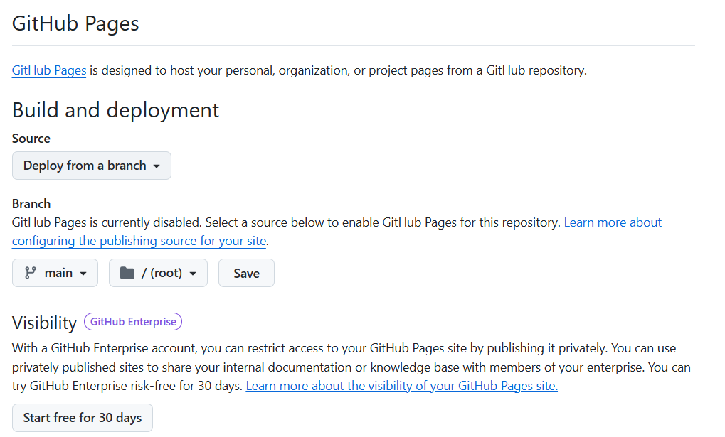
- Click Save.

Done! Your site will be live at:
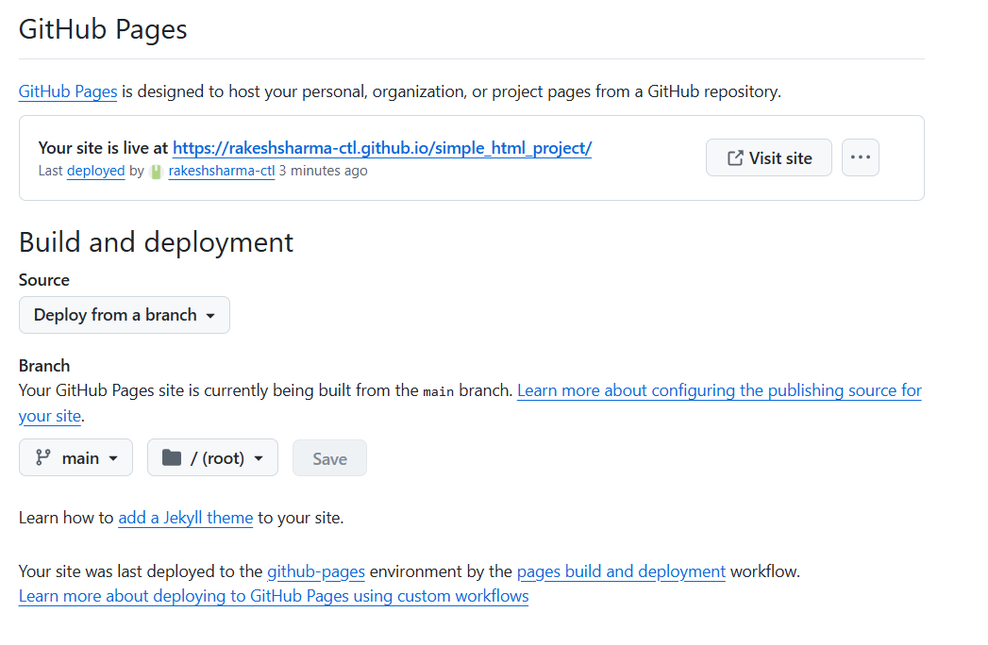
sample url : https://your-username.github.io/repository-name/

